ETL (Extract, Transfer, Load) Operation On AWS Data Glue and Storing It On AWS S3 Bucket
Keywords: ETL (Extract, Transfer, Load), Data Glue, AWS S3 Bucket
Introduction:
What is ETL?
ETL stands for Extract Transform and Load. Extract gets the data from database or other sources, Transform – modifies the data to make it suitable for consumption and Load – Loads the data to the destination (in this case on AWS). This allows data from disparate sources, to be made available on a Data Lake or a Data Warehouse in the same format, so that it can be easily used for reporting and analytics. AWS Glue is one of the AWS ETL tools.
What is AWS Glue?
AWS Glue is an Extract Transform Load (ETL) service from AWS that helps customers prepare and load data for analytics. It is a completely managed AWS ETL tool and you can create and execute an AWS ETL job with a few clicks in the AWS Management Console. All you do is point AWS Glue to data stored on AWS and Glue will find your data and store the related metadata (table definition and schema) in the AWS Glue Data Catalog. Once catalogued in the Glue Data Catalog, your data can be immediately searched upon, queried, and accessible for ETL in AWS.
Prerequisites
Make sure you have the following prerequisites:
- You have an AWS account.
- You have access to AWS Glue.
- Your account has all the necessary permissions for creating and running a job for an Amazon S3 data source and data target.
- You have created an AWS Identity and Access Management role for the job to use. You can also choose an IAM role for the job that includes permissions for all your data sources, data targets, temporary directory, scripts, and any libraries used by the job.

AWS Glue Terminology:
  - AWS Glue Data Catalog,
  - Classifier,
  - Connection
  - Connection
  - Crawler
  - Database
  - Data Store
  - Data Source
  - Data Target
  - Job
  - Script
  - Transform
  - Trigger
When Can We Use AWS Glue:
- You should use AWS Glue to discover properties of the data you own, transform it, and prepare it for analytics.
- Glue can automatically discover both structured and semi-structured data stored in your data lake on Amazon S3, data warehouse in Amazon Redshift, and various databases running on AWS.
Why we need to store in AWS S3 Bucket?
- Reliable Security
- All-time Availability
- Very Low Cost
- Ease of Migration
- The simplicity of Management

How to achieve the ETL operation in AWS Glue?

To achieve ETL operation follow the below steps:
- Firstly, visit the website https://aws.amazon.com.
- Complete Sign Up to create an AWS account.
- Create an IAM Policy for the AWS Glue Service
- Create an IAM Role for AWS Glue
- Create bucket inside the S3 database
- Inside the bucket create one source and target folder
- Inside the source folder add source file from your pc.
- Next step is to create crawler to initiate the glue job.
- Specify the crawler source type and repeat crawls s3 data store
- choose source path from s3 database which was already created
- Choose a data store which is s3 in our case.
- Select s3 and specified path in my account option.
- Select output database and we can also create new database name
- Review all the steps and click create crawler.
- After that select the created crawler and run the crawler
- select the target location from s3 database.

- In the last step we will see the output schema definition.
- Click on run job to start the job.
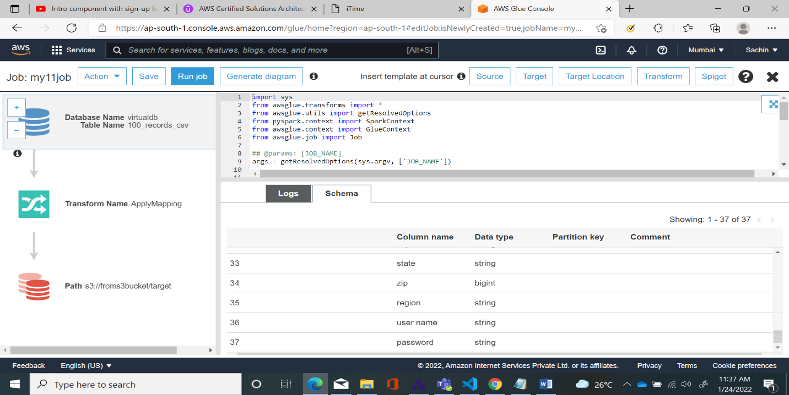
- In the final we will get the desired output in target folder which is in s3 database.
Architecture diagram of AWS Glue
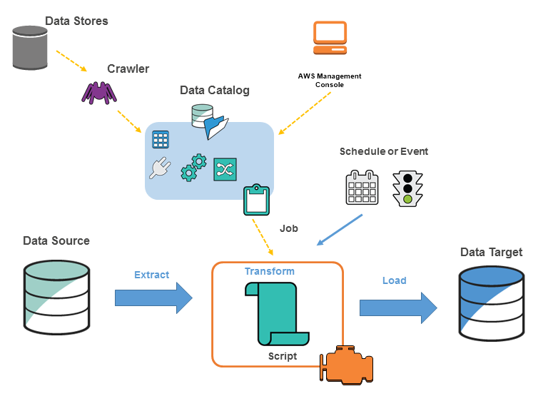
When should you not use AWS Glue?
7 Limitations that come with AWS Glue
- Amount of Work Involved in the Customization.
- Integration with other Platforms.
- Limitations of Real-time data.
- Required Skillset.
- Database Support Limitations.
- Process Speed and Room for Flexibility.
- Lack of Available Use Cases and Documentation.

Benefits of AWS Glue:
- Faster data integration
- Automate your data integration at scale
- No server to manage
Need of AWS Data Glue?
- AWS Glue automates much of the effort required for data integration.
- AWS Glue crawls your data sources, identifies data formats, and suggests schemas to store your data.
- It automatically generates the code to run your data transformations and loading processes.
- You can use AWS Glue to easily run and manage thousands of ETL jobs or to combine and replicate data across multiple data stores using SQL.
- Different groups across your organization can use AWS Glue to work together on data integration tasks, including extraction, cleaning, normalization, combining, loading, and running scalable ETL workflows. This way, you reduce the time it takes to analyze your data and put it to use from months to minutes.
- AWS Glue runs in a serverless environment.
- There is no infrastructure to manage, and AWS Glue provisions, configures, and scales the resources required to run your data integration jobs. You pay only for the resources your jobs use while running.
Use Cases of AWS Glue:
- AWS Glue is recommended when your use cases are primarily ETL and when you want to run jobs on a serverless Apache Spark-based platform.
- AWS Glue is recommended for complex ETL, including joining streams, and partitioning the output in Amazon S3 based on the data content.
- Streaming ETL in AWS Glue enables advanced ETL on streaming data using the same serverless, pay-as-you-go platform that you currently use for your batch jobs.
- AWS Glue generates customizable ETL code to prepare your data while in flight and has built-in functionality to process streaming data that is semi-structured or has an evolving schema.
- Use Glue to apply both its built-in and Spark-native transforms to data streams and load them into your data lake or data warehouse.
AWS Glue Limitations:
- Learning Curve
- Real-time Change Data Capture and transformation for ETL in AWS
- Testing can be a challenge
- Delay in starting jobs
- Lack of control for tables
Conclusion
In this, we explored AWS Glue – a powerful cloud-based tool for working with ETL pipelines. The whole process of user interaction consists of just three main steps. First, you build the data catalog with the help of data crawlers. Then you generate the ETL code required for the data pipeline. Lastly, you create the schedule for ETL jobs.

Reference:
- https://www.tutorialspoint.com.
- Tutorials for Amazon Glue - Amazon Glue
- https://W3Schools Online Web Tutorials.

About the author:

Sachin. holds Bachelor Degree in Electronics and Communication Engineer from Dr. Ambedkar institute of Technology Bangalore affiliated to VTU. He is currently working as Software Engineer with ERS Research team and involved in Data Engineering products development.

